Points of Concurrency
- The circumcenter is the point at which the three perpendicular bisectors of the sides of a triangle intersect. It is also the center of the circle circumscribed around a triangle. This circle passes through all three vertices of the triangle
- The definition of the perpendicular bisector of a side of a triangle is a line segment that is both perpendicular to a side of a triangle and passes through its midpoint.

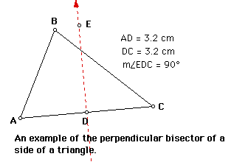

- The incenter is the point at which the angle bisectors of a triangle intersect. It is the center of the circle that can be inscribed in the triangle
- The definition of the angle bisector of a triangle is a line segment that bisects one of the vertex angles of a triangle.
- In general, an angle bisector is equidistant from the sides of the angle when measured along a segment perpendicular to the sides of the angle.
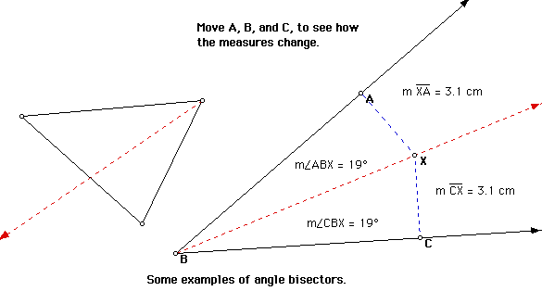

- The centroid is the point at which the medians of a triangle intersect. It is the center of gravity of the triangle.

a. The definition of the median of a triangle is a line segment that extends from one vertex of a triangle to the midpoint of the opposite side.
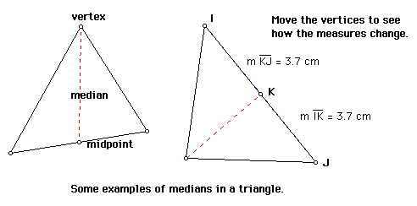

- The orthocenter is the point at which the three altitudes of a triangle intersect.
- The definition of the altitude of a triangle is a line that extends from one vertex of a triangle perpendicular to the opposite side.
- Sometimes the opposite side isn't quite long enough to draw an altitude, so we are allowed to extend it to make an altitude possible.
